**Documentation for NeuralDataAnalyzer version 2.0**

January 16th 2014

SangWook Lee

leealex@uw.edu

Fairhall lab

<http://www.fairhalllab.com>

- Contents

(1) NeuralDataAnalyzer_v2.fig

(2) NeuralDataAnalyzer_v2.m

(3) TestStim.mat

(4) TestSpt.mat

(5) Repeated_testStim.mat

(6) Repeated_testSpt.mat

(7) tools_newglm

(8) tools_revcorrelations

(9) tools_subfig

(10) RunNeuralDataAnalyzer.m

**0. Before you use**

- NeuralDataAnalyzer includes GLM analysis. GLM analysis requires your MATLAB to contains optimization toolbox. If your MATLAB does not have optimization toolbox, GLM analysis will not proceed at fitting procedure.

- GLM analysis in this code is from Dr. Jonathan Pillow’s GLM code. The code is published under the GNU General Public License. I refer all the policy and license here at <http://www.opensource.org/licenses/gp1-3.0.html>

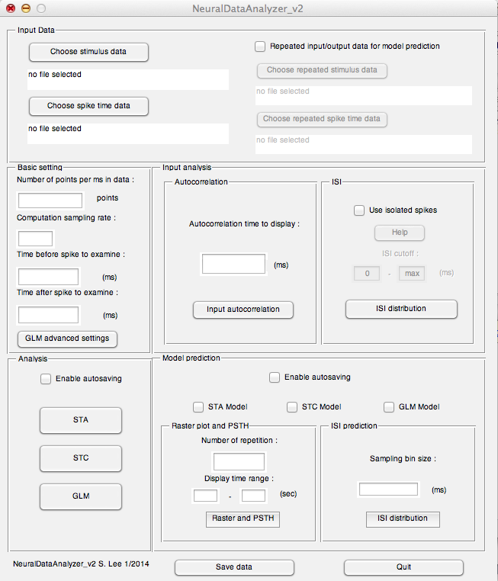

**1. Introduction**

This software has been built to analyze the neural input output data from either electrophysiology experiment for the single neuron unit or biophysical neuron model for characterizing the neural properties of the system. Also using LNP relationship and GLM filters, it generates the spike time of each model to predict and compare the spike timing and inter-spike intervals, with given repeated input stimulus data. I am anticipating this program can be useful for those who are interested with studying single neuron properties of various neuron types.

**2. Input Data Panel**

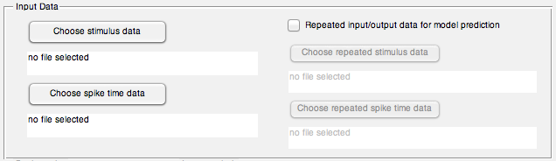

This is the first step of the program. The user chooses the input stimulus and spike time data by pressing ‘Choose stimulus data’ and ‘Choose spike time data’ button respectively. Both stimulus and spike time data should be save with file extension *.mat, which is MATLAB’s data file extension. *.mat file that user is using for the program needs to contain only one data each although its name can be any name user has saved. If the user clicks the button, the pop-up window appears to browse the file in the folder.

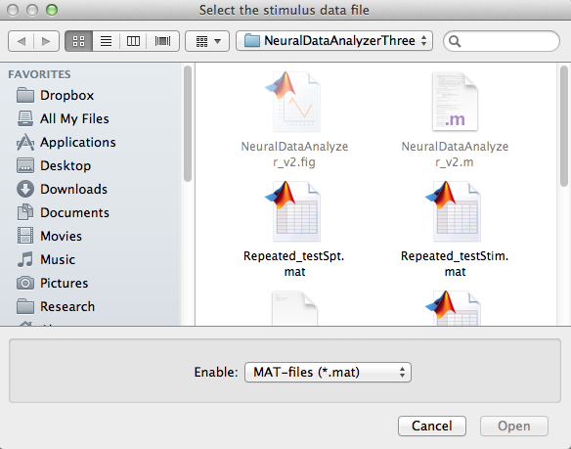

As an example, ‘TestStim.mat’ has been selected for the stimulus and ‘TestSpt.mat’ has been selected for the spike time data. Both files are available in the zip file. The selected example data is from the simulation data using biophysical model of rat’s motoneuron.

**3. Basic setting panel**

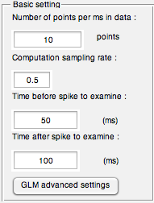

Basic setting panel takes a few parameter values that need to be specified along with the given data and analysis. In order to perform the temporally exact computation and plot the result, the number of points that represents the time unit needs to be specified. Also, for the resolution of filters that are calculated from reverse correlation method, user needs to specify the data sampling rate. The length of spike triggered average to display can be specified in the unit of time. This will be the length of all the features calculated by reverse correlation analysis, covariance analysis, and maximum likelihood(GLM). Since fitting filters with maximum likelihood examines the intrinsic property of the system(i.e. effect of spike history to the proceeding spike), the length of time to examine after spike needs to be specified. For example data, 10 points, 0.5, 50 ms, and 100 ms are used respectively.

**3-1 GLM advanced settings (optional)**

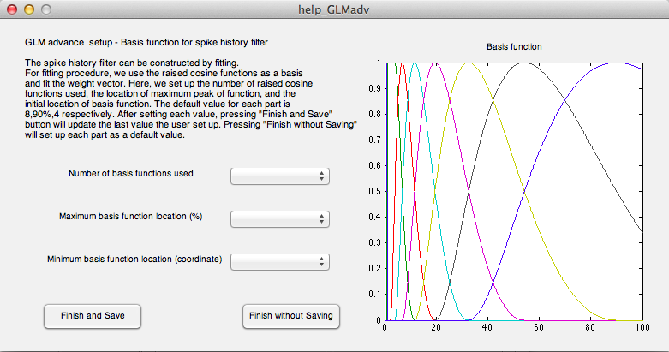

Optional GLM advanced setup. The spike history filter can be constructed by maximum likelihood. For fitting procedure, we use the raised cosine functions as a basis and fit the weight vector. Here, we set up the number of raised cosine functions used, the location of maximum peak of function, and the initial location of basis function. The default value for each part is 8, 90%, and 4 respectively. After setting each value, pressing “Finish and Save” button will update the last value the user set up. Pressing “Finish without Saving” will set up each value as a default.

**4. Input analysis panel**

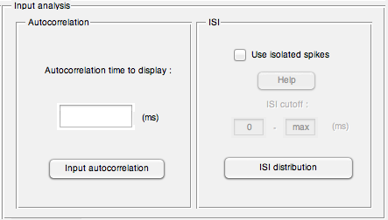

This panel is for analysis of the given input stimulus and spike time data.

**4-1 Autocorrelation panel**

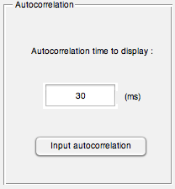

Autocorrelation of input stimulus can be calculated to identify the temporal correlation of input with itself. As an example, 30 (ms) has been chosen to display.

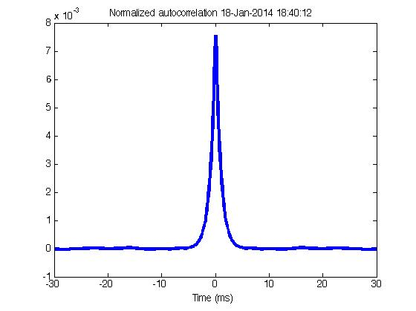

**4-2 ISI panel**

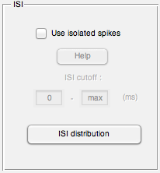

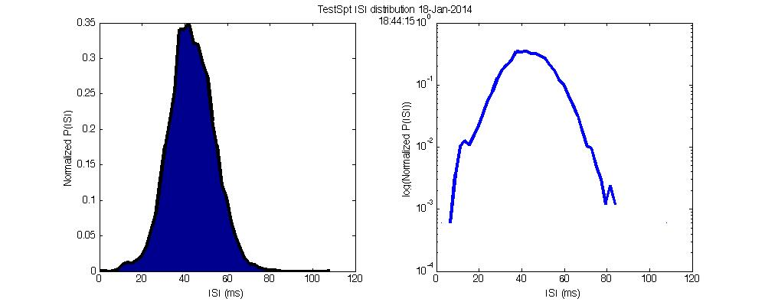

Inter-spike interval distribution of given spike time data can be displayed by pressing ISI distribution button. The left shows up the normalized ISI distribution plot with area curve. And the logarithm of the ISI distribution folder is displayed to the right.

The spikes that have certain inter-spike interval with the previous spike can be chosen for the further analysis by checking ‘Use isolated spikes’ check box. The user chooses the ISI range that will be used for the analysis.

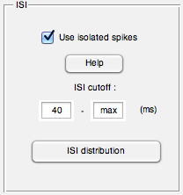

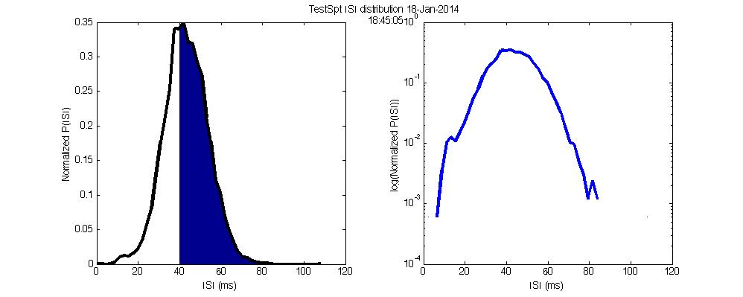

**5. Analysis panel**

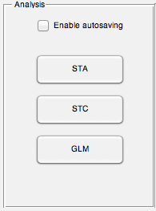

Reverse correlation constructs linear-nonlinear model with the given stochastic random stimulus and spike time data. STA button in the panel computes the average stimulus trajectory preceding spikes for the linear portion of the model. Multiple features(2 features in this program) can be considered and computed in this context to predict the more accurate timing of spike by using STC model. And using sampled data and Bayes’ theorem, nonlinear relation of the stimulus and spike time data can be approximated.

In order to include the intrinsic effect of spike generation, generalized linear model(GLM) has been added. In the framework of the GLM, the probability of a spike depends nonliearly on a linear combination of stimulus and self-activity. When the nonlinearity is chosen from log-concave function family, the linear coefficients of models can be fit efficiently using maximum likelihood methods. Basic exponential function has been used as nonlinearity for this program.

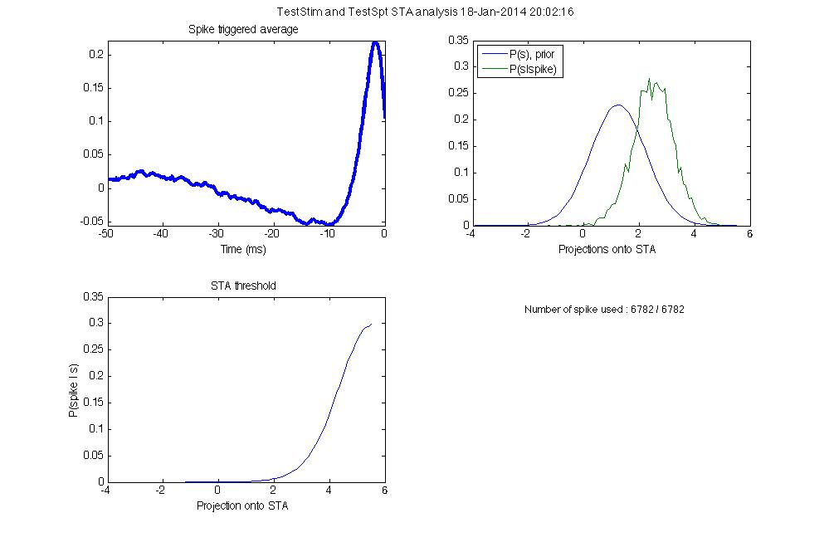

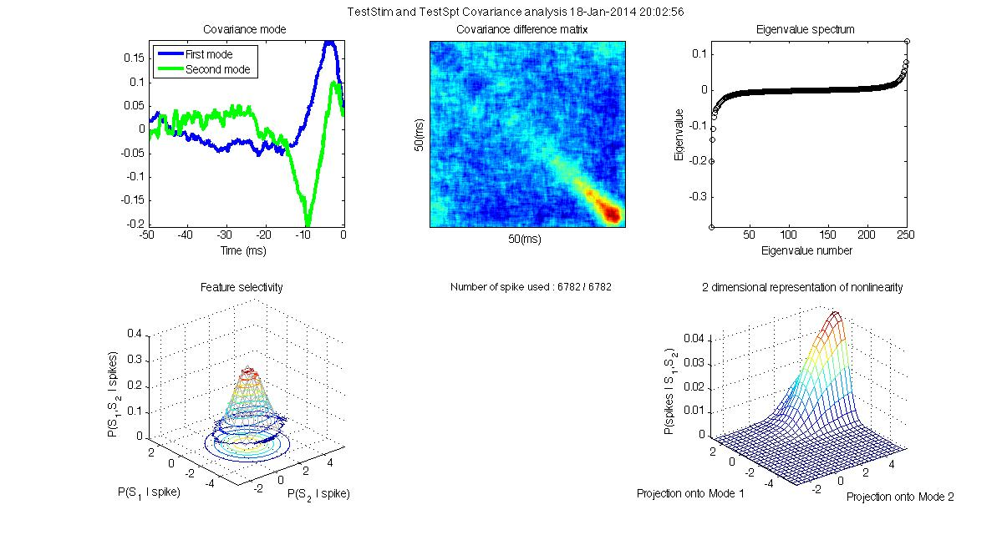

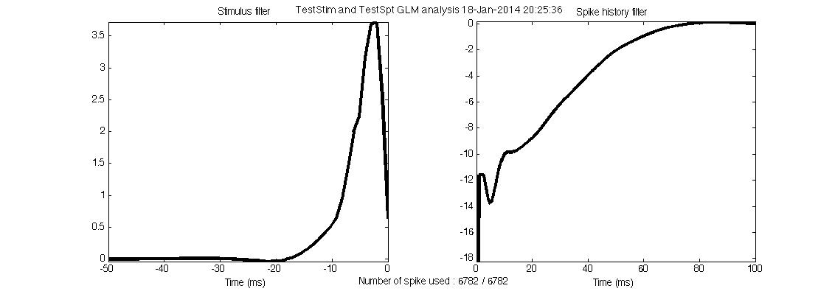

Checking ‘Enable autosaving’ check box will save the figure automatically.

**6. Model prediction panel**

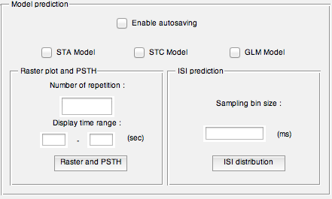

After constructing the model with a given input/output data, the user can generate and predict the right spike timing using either initially given input/output data or a new set of repeated input/output data. The user indicates the new set of repeated input/output data by checking the ‘Repeated input/output data for model prediction’ check box of ‘Input Data’ panel. Checking the box will enable the additional press button so that the user can browse the folder to choose the repeated input/output data.

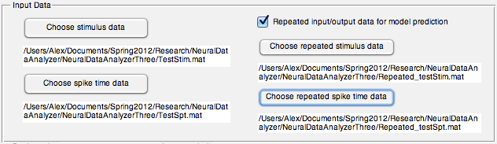

If the user does not specify the repeated input/output data and press either ‘Raster plot and PSTH’ or ‘ISI distribution’ button in ‘Model prediction’ panel, the program will cast the warning message, saying that the program will use originally given input/output data for predicting spike timing and generating ISI distribution.

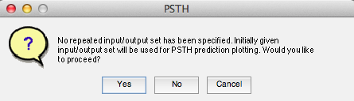

**6-1 Raster plot and PSTH panel**

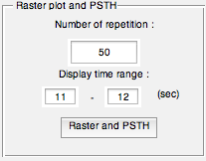

Using the spike time data using each model, the raster plot and PSTH can be generated in this panel. The user needs to specify the number of repetition and time range to display. For an example, 50 repetitions of 11 sec to 12 sec repeated data have been used to display the raster and PSTH plots.

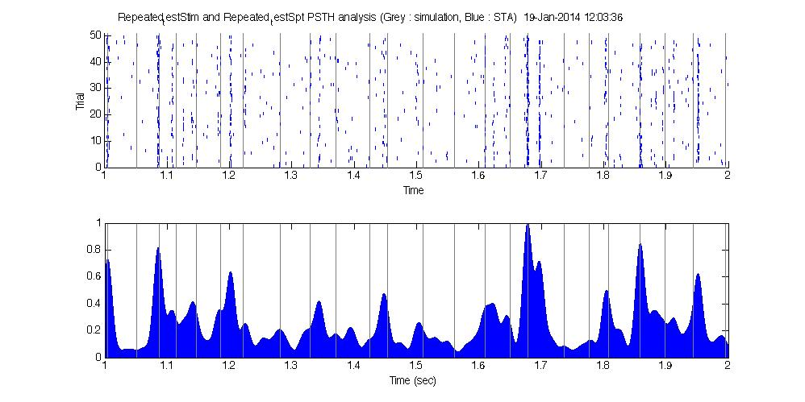

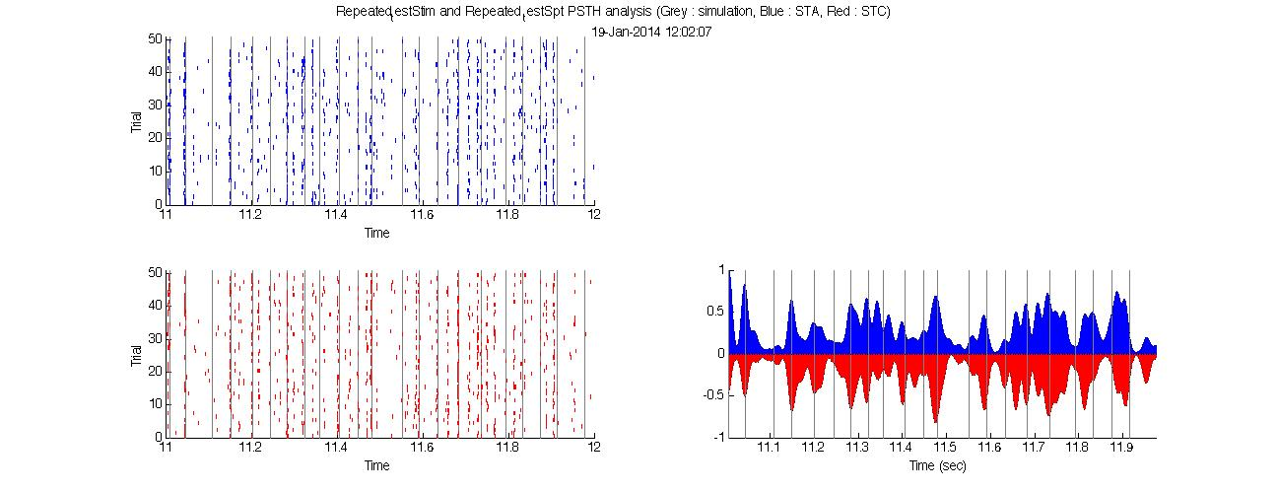

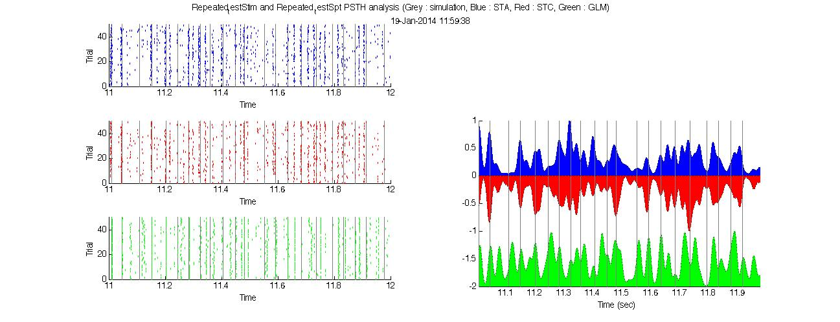

**6-2 ISI prediction panel**

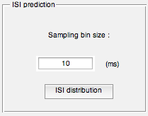

Each Model’s ISI distribution comparison with the given data can be calculated in this panel. The user needs to specify the sampling bin size of inter-spike interval distribution. For an example, 10 (ms) of bin size has been used to produce the ISI distribution of all models.

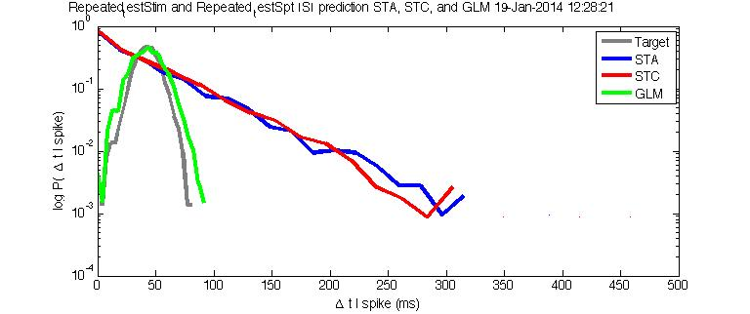

**7. Saving data**

Alex's macbook:Users:Alex:Documents:Spring2012:Research:MatlabGUIProject:4ADreporting2:Screen Shot 2014-01-20 at 9.00.19 AM.png

‘Save data’ button will create a new *.mat file that contains all created data in current session.